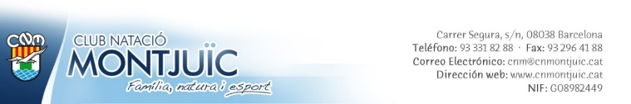

## Individual acceptance of the Protocol

I, ....................

with ID Number............................................, from the organisation CLUB NATACIÓ MONTJUÏC

And according to my responsibilities as (user, member, director, coach, trainer, monitor, caretaker, president, maintenance, cleaning, administration, trainee, etc.)

Sign this document confirming that:

* I am aware of the Protocol for the detection, action, and prevention of child and adolescent sexual abuse and violence, and I undertake to respect and apply it.
* I am aware of who the person in charge of child and adolescent protection is and how to get in touch with them.
* I have the notification circulars and the corresponding contact details.

In Barcelona on ............... .......................... 2023

Signed